

Dr. Sarah, Sanchez inc.

2016-10-24

Dr. Sanchez

123 Stevens Well, Anitamouth, SD 19226

Phone: 6437278725

Fax: 7213094266

**Re:** Sophia, Rodriguez

**PHN:** 3852868857

**Birthdate:** 06-Oct-1959

**Address:** 78127 Rebecca Alley, Juliestad, MN 78589

**Patient number:** 4351505509

To Whom It May Concern:

This is a medical letter to state the above patient is pregnant with expected delivery date of 02-Feb-2025. Hoping this information is satisfactory for your requirements.

Thank you.

Sincerely,

Dr. Sarah, Sanchez

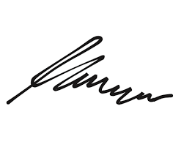

FRCS© NCMP

Clinical Assistant Professor, UBC

Department of Obstetrics and Gynecology SMH